A Project Report on

# **HAPTIC GAMING ASSISTANT USING AI**

*In partial fulfillment of the requirements for the award of the degree of*

**Bachelor of Technology**

In

**Electronics and Communication Engineering**

*Submitted by*

**Aditya Bhonsle**, 174201

**Bhagan Ram**, 174206

**Kancharla Sai Kowshik**, 174218

*Under the esteemed guidance of*

**Dr. K.L.V. Sai Prakash Sakuru**

**Associate Professor**



**ECE Department, NIT Warangal**

**Department of Electronics and Communication Engineering NATIONAL INSTITUTE OF TECHNOLOGY WARANGAL - 506004 (Telangana)**

**DEPARTMENT OF ELECTRONICS AND COMMUNICATION ENGINEERING**

**NATIONAL INSTITUTE OF TECHNOLOGY**

**WARANGAL - 506004**



CERTIFICATE

This is to certify that the project work titled “***Haptic Gaming Assistant Using AI***” is a bona fide record of work carried outby **Mr. Aditya Bhonsle (Roll No. 174201), Mr. Bhagan Ram (Roll No. 174206) and Mr. Kancharla Sai Kowshik (Roll No. 174218)** , submitted to the faculty of Department of Electronics and Communication Engineering in partial fulfillmentof the requirements for the award of the degree of **Bachelor of Technology** in Electronics and Communication Engineering at National Institute of Technology, Warangal during the academic year 2020 – 2021.

|  |  |
| --- | --- |
| **Dr. K. L. V. Sai Prakash Sakuru** | **Dr. Anjaneyulu** |
| Associate Professor | Head of Department |
| Dept. of Electronics and Communication Engineering | Dept. of Electronics and Communication Engineering |
| National Institute of Technology | National Institute of Technology |
| Warangal | Warangal |

ACKNOWLEDGEMENT

We wholeheartedly thank our guide **Dr. K. L. V. Sai Prakash Sakuru, Associate Professor**, Department of Electronics and Communication Engineering, for being a source of motivation, constant supervision and invaluable encouragement, and for guiding us with perfection in doing this work.

We would also like to show our gratitude to our Project Coordinators: **Dr. A. Prakasa Rao sir,**  **Dr. Amarjit Kumar sir** and **Dr K. Prakash sir** and **Dr. Anjaneyulu sir (Head of Departement)** for their continuous help and monitoring during the project work.

We consider it as a great privilege to express our deep gratitude to many respected personalities who guided, inspired and helped us in the successful completion of the project.During the work we faced many challenges due to lack of our knowledge and experience but these people helped us to get over from all the difficulties.

We are also thankful to all our friends who have given valuable suggestions and help in all stages of the development of the project.We consider it as a great privilege to express our deep gratitude to many respected personalities who guided, inspired and helped us in the partial completion of the project.

In the end we would like to thank our department (Electronics and Communication Engineering) for providing such an opportunity to learn from all these experiences.

Thank you All,

Aditya Bhonsle - 174201

Bhagan Ram - 174206

Kancharla Sai Kowshik - 174218

|  |  |  |
| --- | --- | --- |
|  | CONTENTS | Page No |

1 CERTIFICATE II

3 ACKNOWLEDGEMENT III

4 CONTENTS IV

LIST OF FIGURES V

LIST OF TABLES VI

**Chapter 1** 1 INTRODUCTION 1

1.1 Problem Description and Statement 1

1.2 Aims and Objectives 1

1.3 Scope of Work 2

1.4 Applications 2

1.5 Advantages 2

1.6 Limitations 2

**Chapter 2** 2 Literature Review 3

**Chapter 3** 3 Design of hardware 5

3.1 Specification of Hardware Used 5

3.2 Selected Physical Model for Assistant 6

3.3 Proposed Hardware Implementation 7

3.4 Arduino-3D Assistant Control Flow 10

**Chapter 4** 4 Design of Software 11

4.1 Endless Jump Game Mechanics 11

4.2 Arduino Motor Signal Control Flow 12

4.3 Unity ML-Agents Control Flow 13

**Chapter 5** 5 Design of HARDWARE-sOFTWARE INTERFACE 14

5.1 Feedback Control Mechanism 14

5.2 Serial Communication Specifications 15

5.3 Serial Communication Flow Control 15

**Chapter 6** 6 RESULTS & Discussion 16

6.1 Hand Gesture Recognition using 2DConvNN: 16

6.2 Chrome Dino Game AI using DQN 18

6.3 Flappy Bird Game AI using NEAT 20

6.4 Training AI using Unity ML-Agents 22

6.5 3D-Printing Physical Model for Assistant 27

6.6 Mechanical Assembly of 3D-Printed Parts 27

6.7 Adding Electronic Components 29

6.8 Creating Working Prototype using Arduino 31

6.9 Arduino Unity-C# end-to-end Serial Communication 34

6.10 AI Controlled Haptic Assistant 35

**Chapter 7** 1 CONCLUSION 39

7.1 Future trends and work 40

1 REFERENCES 41

1. LIST OF FIGURES

Fig 3.2.1: Image of 3D design model of Hand Controller[1]©Alex Czech 6

Fig 3.3.1: Arduino Interfacing Circuit Diagram 7

Fig 3.3.2: Complete Circuit Diagram Schematic 8

Fig 3.3.3: DC Motor Physical Dimensions 8

Fig 3.4.1: Arduino Control Flow Diagram 10

Fig 4.1.1: Control Flow of Endless Jump Game 11

Fig 4.2.1: Arduino Motor Control Flow 12

Fig 4.3.1: Unity ML-Agents Control Flow Diagram 13

Fig 5.1.1: Block Diagram for Controlling Assistant 14

Fig 5.3.1: Serial Communication Interface 15

Fig 6.1.1: Hand Gesture Types 16

Fig 6.1.2: Confusion Matrix 17

Fig 6.1.3: Model Loss vs Epoch 17

Fig 6.2.1: Action Space 18

Fig 6.2.2: Chrome Dino Run Game Actions 18

Fig 6.2.3: Game Over Still 18

Fig 6.2.4: Chrome Dino DQN Initial Training Steps 19

Fig 6.2.5: Chrome Dino DQN After Episode Replay 20

Fig 6.3.1: Flappy Bird Game Still 20

Fig 6.3.2: NEAT Hyper-parameters[11] 21

Fig 6.3.3: NEAT Flappy-Bird Metrics 22

Fig 6.4.1: 3D Ball Game Still [10] 23

Fig 6.4.2: Hyper-parameters for 3DBall Environment 24

Fig 6.4.3: Environment Metrics 24

Fig 6.4.4: Training Loss Metrics 25

Fig 6.4.5: Training Policy Metrics 26

Fig 6.5.1: 3D-Printed parts of Assistant 27

Fig 6.6.1: Front View of Assembled Parts 28

Fig 6.6.2: Top View of Assembled Parts 28

Fig 6.7.1: DC Motor Fitting and Wiring Side View 29

Fig 6.7.2: DC Motor Wiring Back View 29

Fig 6.7.3: Flex sensor Interface with Arduino 30

Fig 6.7.4: Flex Sensor placing on Assistant 30

Fig 6.8.1: Completely Assembled 3D Hand Assistant 31

Fig 6.8.2: Motors in Up Motion Still 32

Fig 6.8.3: Arduino Test Input and Sensor Values for Down 32

Fig 6.8.4: Motors in Down Motion Still 33

Fig 6.8.5: Arduino Test Input and Sensor Values for Down 33

Fig 6.9.1: Before “Left” Signal from Unity 34

Fig 6.9.2: After “Left” Signal Completed from Arduino 34

Fig 6.9.3: Serial Communication Log 35

Fig 6.10.1: Environment Metrics of Jumping Car AI 36

Fig 6.10.2: High Score in Episodes of Jumping Car AI 36

Fig 6.10.3: Loss Metrics of Jumping Car AI 36

Fig 6.10.4: Policy Metrics of Jumping Car AI 36

Fig 6.10.5: Other Policy Metrics of Jumping Car AI 37

Fig 6.10.6: Game AI Controlling Motor 1 as it senses obstacle 37

Fig 6.10.7: Score Update after successful attempt 38

Fig 6.10.8: Serial Communication Log for Final Prototype 38

1. LIST OF TABLES

Table 3.3.1 Flex Sensor Thresholds 7

Table 3.3.2 Motor Pin State Lookup Table 9

Table 6.9.1 Arduino Unity Look-up Table 34

Table 6.10.1 Arduino Unity Lookup Table 35

# Chapter - 1

1. INTRODUCTION
   1. Problem Description and Statement

Next-generation gaming experience has been revolutionized with VR/AR. This has lead to development of controllers and is active area of research. New users need assistance while playing with these controllers for first time.

* 1. Aims and Objectives

The main objective of this project-work is integrating two independent ideas: Gesture Controlled 3D Printed Exoskeleton Hand using Arduino and AI playing Game.We wish to develop assistant that will help new player play the game by moving the required fingers needed using the AI's help. The overall objectives to be achieved in this study are:

1. Use Open-Source model of Haptic Feedback Exoskeleton Hand
2. Create Simulation Environment for Training and Testing using Unity/Python
3. Use AI to control movement of assistant while taking input from Simulation Environment

* 1. Scope of Work
* We will create a controller for hand using 3D-Printing from existing open-source design and add movement using Bi directional DC Motors, Flex-sensor and Arduino.
* We are using 3D-printed model which can directly interact with hand as opposed to the conventional keypad and joystick controller which offer limited interaction. Hence
* We will create game environment in Unity3d and use its ml-agents package for training AI model using various algorithms.
* This design makes the controller more human friendly and interactive.
  1. Applications
* Guides player to play correctly
  + Saves time and extra effort.
* Extending the idea by using a complete exoskeleton, we can make trainers for:
  + martial arts, dancing, playing instrument, VR gaming, etc.
  1. Advantages
* Using 3D-printed model which can directly interact with hand and improves overall experience.
* This design makes the controller more human friendly and interactive.
  1. Limitations
* Can't play complex games due to
  + Feasible AI models can play simple games
  + Current model has Single DOF for each finger
  + End to end latency is ~2000 ms.

# Chapter - 2

1. Literature Review

**Mauricio Orozco and others**[12] discussed and elaborated in their research paper ‘ **The Role of Haptics in Games** ’ about the new era where the computers are miniaturized with even higher capacities of processing and memory and how the current generation developers and researchers have focused on implementing the sensory experience to include the sense of touch. Vibrotactile feedback is one the first implementations of haptic feedback using vibrations with a rumble effect on game input controllers. For achieving a more immersive experience, other haptics modalities particularly force feedback have been explored. It was stated that by using existing, well-developed game engine components such as Unity 3D, a scene graph library and physics engine, and augmenting them with the design and implementation of haptic rendering algorithms, it is possible to create a highly useful haptic game development with force feedback.

Haptic devices are available in a consumer marketplace with complex hardware implementation, they allow for more realistic reactions from the controller to game dynamics and user actions. Currently, steering wheels and vibration feedback joysticks are widely used as input devices for video games. Haptics was a game changer in the industry and it has instigated new forms of features and complexity in the game development by emulating the user experience based on this particular bidirectional feedback.

Haptics was introduced as a valuable technology to help gamers to have more immersive and realistic experiences, there is yet another need for which haptics is of essential value. Gaming with haptics is a well suited type of interaction to tackle the problem of accessibility to games for the physically and visually impaired.

**Zhou MA and Pinhas Ben-Tzvi**[13] explained in their research paper ‘ **Sensing and Force-Feedback Exoskeleton (SAFE) Glove** ’about their design, implementation and experimental validation of a portable and lightweight haptic exoskeleton glove which measures and assists user’s hand motions with a five finger mechanism with motors through the routed cables at each of the finger as force actuators for providing a force feedback to the hand of the user. The haptic gloves used controllable dampener to provide resistance force. The user can feel the force when the actuator is engaged.

The mechanical design was compact without compromising the natural human finger movements and motions. The total weight of the prototype was around 275 grams. Each finger consisted of three linkages with a single actuator driving them except thumb which had four linkage due to its unusual geometry.

For the experimental results on assisting hand movements, a 3D graphical user interface was programmed based on an open-source framework for haptics and dynamics simulations with C++ to show the hand kinematics in real time. The 1St step of this experiment was to record joint motions and finger pressures in the pick-and-place task. The 2Nd step was to prompt these movement and motion patterns in playback fashion to assist a weakened hand to perform these movements. The glove was programmed to assist the user’s fingers to follow the position and force trajectory from the previously recorded data. The results shown that the designed glove is capable of recording and assisting the hand function in simple hand gestures and movements.

**Volodymyr Mnih and others**[14] demonstrated in their research paper ‘ **Playing Atari with Deep Reinforcement Learning** ’on how a convolutional neural network can overcome these challenges to learn successful control policies from raw video data in complex RL environments and successfully made a deep learning model to learn control policies from high dimensional sensory input using reinforcement learning and applied them to the classic arcade ‘ Atari 2600 ’ and successfully outperformed all the previous approaches including human expertise. For updating the weights, the network was trained with stochastic gradient descent and a variant of the Q-learning algorithm. To relieve the problems of non-stationary distributions and correlated data, they used an experience replay mechanism which randomly samples previous transitions, and eases the training distribution over many past behaviors. The network wasn’t provided with any particular game specific information and was unknown of the internal state of the emulator.

This paper introduced a new deep learning model for reinforcement learning, and demonstrated its ability to master difficult control policies for some of the classic arcade games using raw pixels as input and also presented a variant of online Q-learning that combines a set of random variable subsets of data updates with experience replay memory to ease the training of deep networks for Reinforcement learning.

# Chapter - 3

1. Design of hardware
   1. Specification of Hardware Used

* 3D Printing Model (15cm x15cm)
  + Filament material: ABS
  + Resolution:0.2mm
  + File Format: STL
  + Infill : 50%
* Arduino Mega 2560 R3
  + MCU: ATmega2560
  + Architecture: AVR
  + Operating Voltage: 5V
  + Clock Speed: 16 MHz
  + Flash Memory: 256 KB (8 KB used by bootloader)
  + SRAM: 8 KB
  + EEPROM: 4 KB
  + Digital IO Pin: 54 ( 15 Pins of PWM)
  + Analog Input Pins: 16
* Bi-directional DC Motors:
  + Voltage:6V
  + RPM:30
* Flex Sensors:
  + Voltage: 0-5V
  + Flat Resistance: 25K Ω
  + Bend Resistance Range: 45K to 125K Ohms(depending on bend)
* Nuts & Bolts
  + M6 x 18mm
  + M9 x 50mm
  + M6 x 12mm

* 1. Selected Physical Model for Assistant

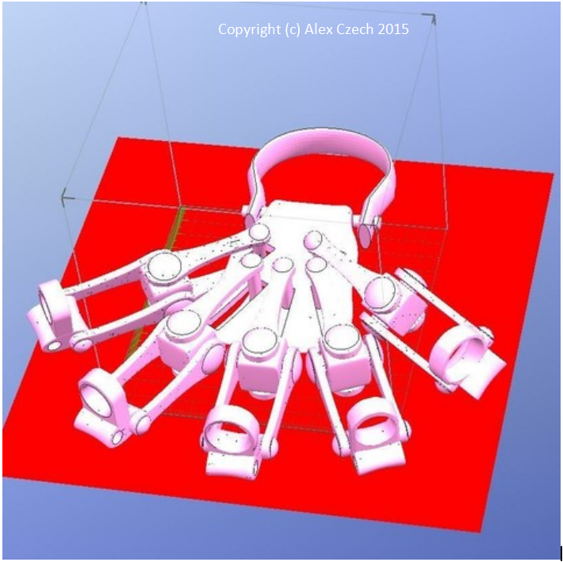

* + 1. Image of 3D design model of Hand Controller[1]©Alex Czech
  1. Proposed Hardware Implementation

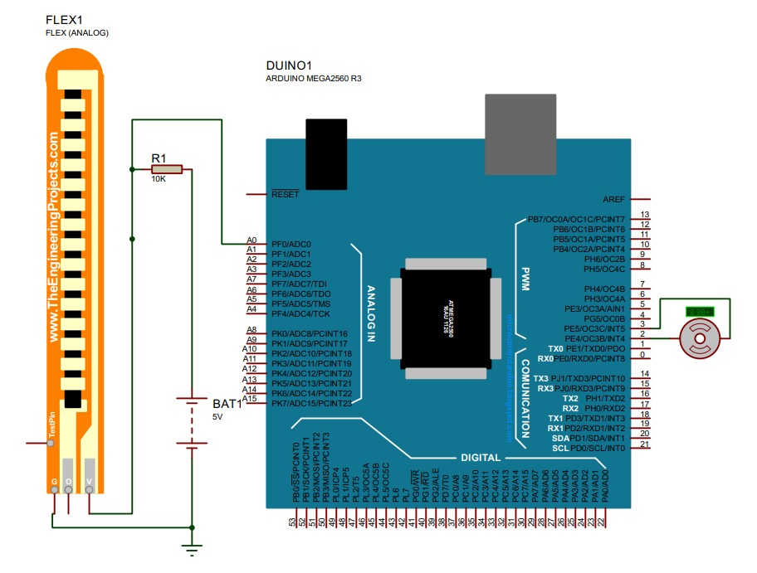

* + 1. Arduino Interfacing Circuit Diagram

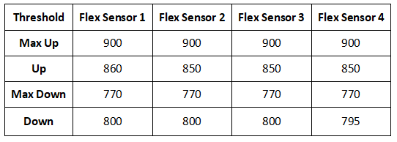

**Table 3.3.1 Flex Sensor Thresholds**

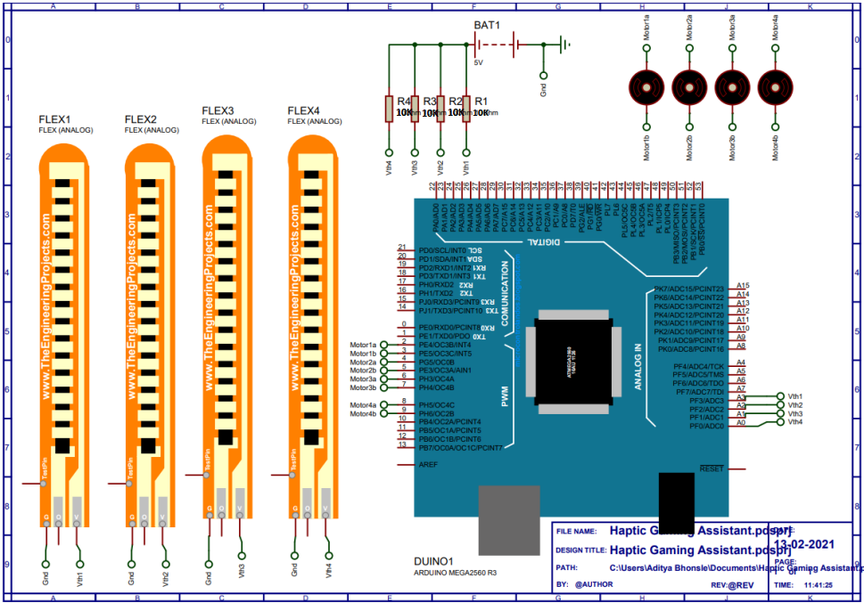

* + 1. Complete Circuit Diagram Schematic

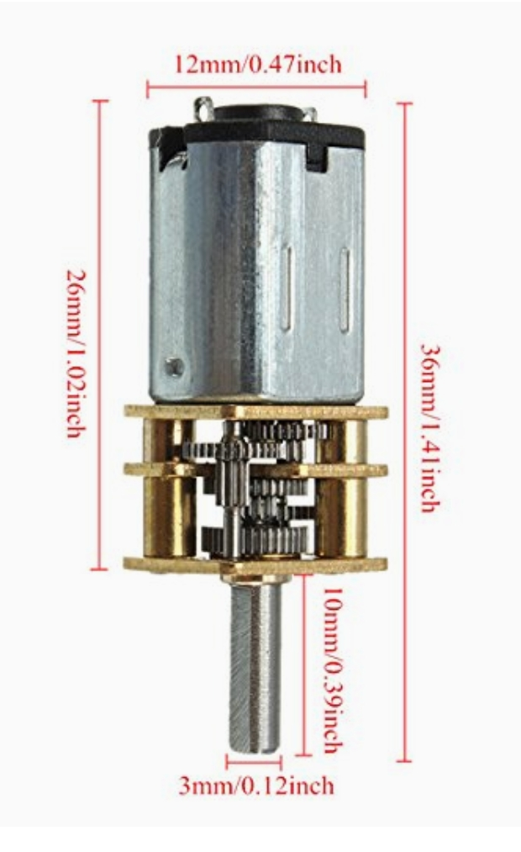

* + 1. DC Motor Physical Dimensions

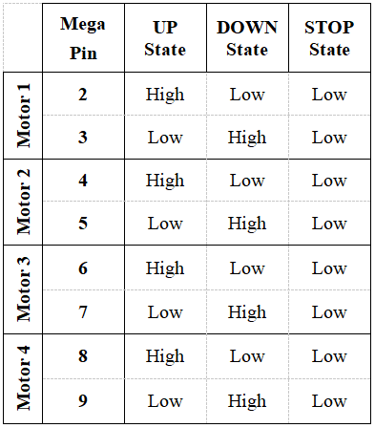

Table 3.3.2 Motor Pin State Lookup Table

* 1. Arduino-3D Assistant Control Flow

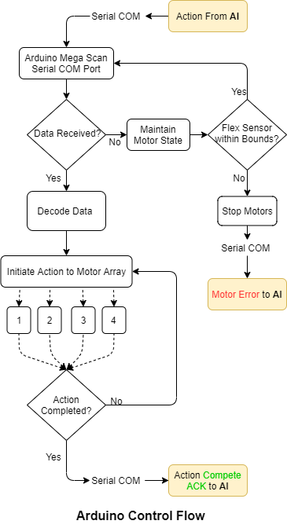

* + 1. Arduino Control Flow Diagram

# Chapter - 4

1. Design of Software
   1. Endless Jump Game Mechanics

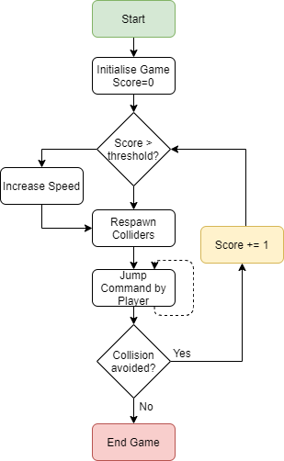

* + 1. Control Flow of Endless Jump Game

* 1. Arduino Motor Signal Control Flow

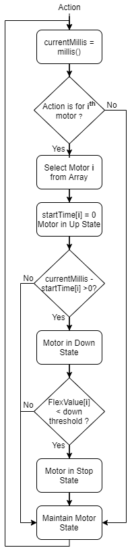

* + 1. Arduino Motor Control Flow

* 1. Unity ML-Agents Control Flow

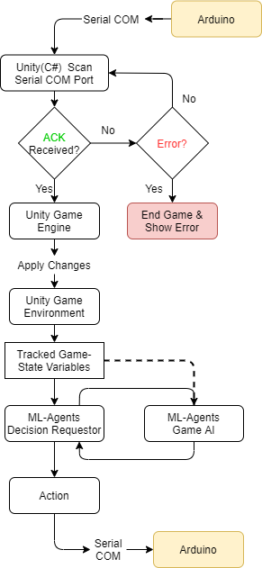

* + 1. Unity ML-Agents Control Flow Diagram

# Chapter - 5

Design of HARDWARE-sOFTWARE INTERFACE

* 1. Feedback Control Mechanism

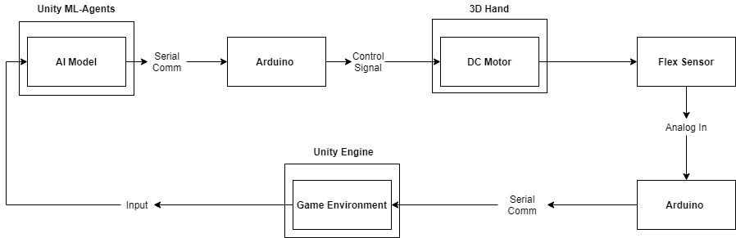

* + 1. Block Diagram for Controlling Assistant
  1. Serial Communication Specifications
* Unity
  + Library Used: System.IO.Ports (.Net 4.x)
  + Baud Rate: 115200
  + Parity: None
  + COM Port: 7
  + Stop Bits: 1
  + Read Timeout: 1
  + Write Timeout: 1
  + Dtr Enable: False
* Arduino
  + Library Used: Serial.h
  + Baud Rate: 115200
  1. Serial Communication Flow Control

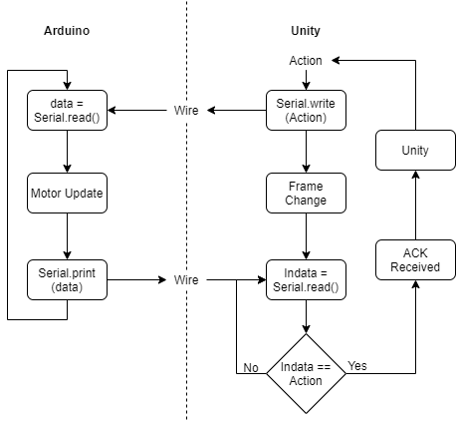

* + 1. Serial Communication Interface

# Chapter - 6

1. RESULTS & Discussion
   1. Hand Gesture Recognition using 2DConvNN:

Hand gesture recognition database is presented, composed by a set of near infrared images acquired by the Leap Motion sensor. The database is composed by 10 different hand-gestures that were performed by 10 different subjects (5 men and 5 women).

Using Conv2D class from Keras Sequential Library is used create neural net model which can recognize the hand gesture . It is 2D Convolution Layer, this layer creates a convolution kernel that is wind with layers input. Images are grey-scaled and resized as square for better feature identification.

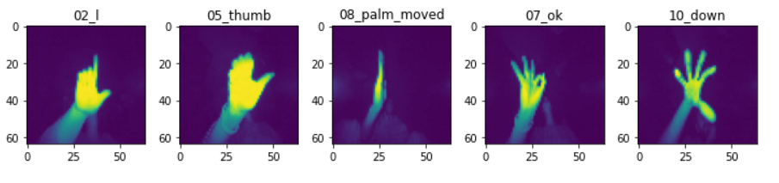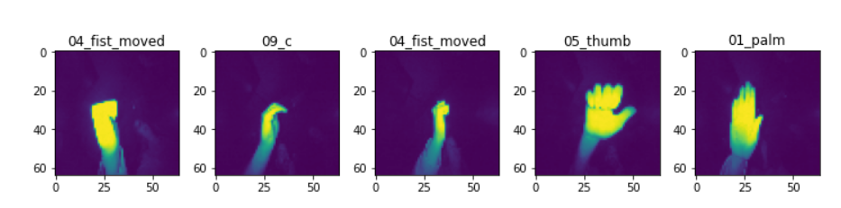

* + 1. Hand Gesture Types

We use model which has three Conv2D layers for extracting features with Max-Pooling for downscaling, ‘relu’ activation and later layers consists of two Dense layers for for classification into types from the features extracted.

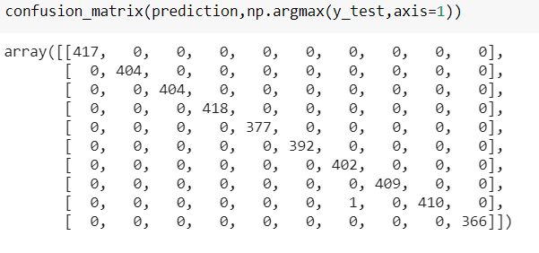

* + 1. Confusion Matrix

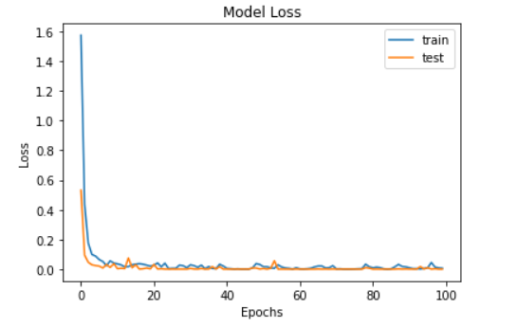

* + 1. Model Loss vs Epoch

As seen from the confusion matrix above the model is able to classify the images into their respective classes with nearly all but one image. While the Fig 6.1.3 we see steep decline in model loss in earlier epochs as model is learning and later settles under 0.2 and there is consistent between train and test.

* 1. Chrome Dino Game AI using DQN

Simple endless jump game where main aim is to dodge the obstacle by either jump or duck. With increasing score the difficulty increases as speed of re-spawn of obstacle increases. We have tried creating this environment in Unity using its Physics Engine and C# scripts.

The chrome-dino game from gym_dino_game is used as environment for DQN model. First the model is trained for some episodes and according to reward obtained the model learns. After these episode replay is done as discussed before where some random states are adjusted and replayed with model. Then model is retrained as before and model is evaluated.

The input is processed with three layered Conv2D and one hidden layer where the game runs at 10 frames per sec. The possible actions are as follows:



* + 1. Action Space

And the reward policy of DQN is reward of 0.1 is added for every step &penalty of -1 is added if game crashed/ended.

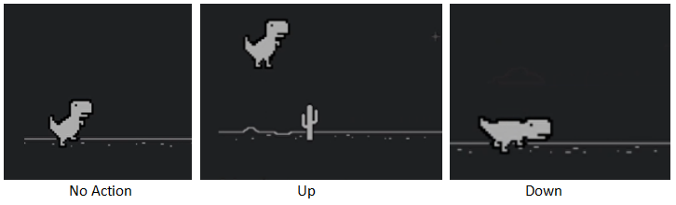

* + 1. Chrome Dino Run Game Actions



* + 1. Game Over Still

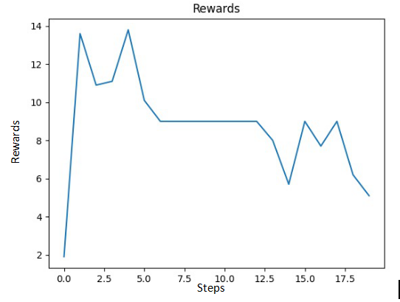



* + 1. Chrome Dino DQN Initial Training Steps





* + 1. Chrome Dino DQN After Episode Replay

Here we can see that DQN algorithm is not preforming quite well and will require further training steps for model to learn playing the game. As the model is feed with more steps it will realize when to jump as it will increase the score and in turn not end gameplay and increase score even further.

* 1. Flappy Bird Game AI using NEAT

This resembles to chrome dino with slight variation, where with each tap the bird is provided with thrust. And by adjusting the trajectory of bird with taps the obstacles must be avoided. In sense this is fast paced version of chrome dino. We have created this environment in python using pywin library.



* + 1. **Flappy Bird Game Still**

Neural network mainly have these topologies: Inputs, Outputs, Activation function, population size, Fitness function and max generations. For our flappy bird game inputs are: position of bird, top pipe and bottom pipe. The output of our neural network is either the bird jump or not. Activation function which will decide that when the bird have to jump and when not. Here we are using tanh hyperbolic function which has the values between 1 and -1 only.

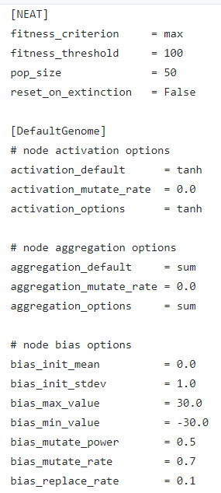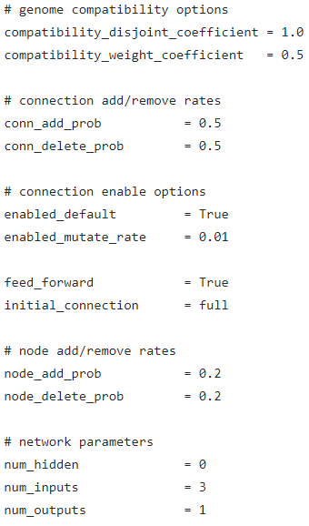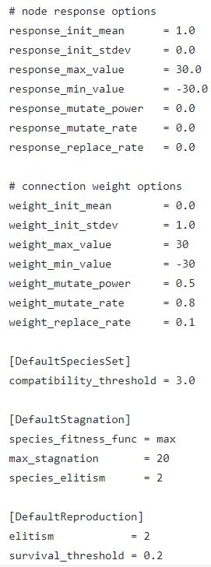

* + 1. NEAT Hyper-parameters[11]

So we can decide that if the value is greater than 0.5 than it has to jump else not. We can choose other values like 0 but it works good for 0.5. Now the next is population size which means how many birds we gonna have for running in each generations. Here we are taking 100 birds for gen 0. Now we will test all this birds and we will take the best of these birds, breed them, mutate them and create another 100 birds for next generation. These birds will give better output than the previous because these came from best of the previous gen and we will keep doing this again and again until we get the best bird.

Now next is fitness function which is the most important part of NEAT algorithm. It tells the how the bird good are. For our neural fitness function is how far or how much distance the bird has travelled i.e how far the birds goes. Next part is max generation up-to which we run this algorithm. Here we selected 30 max generations.

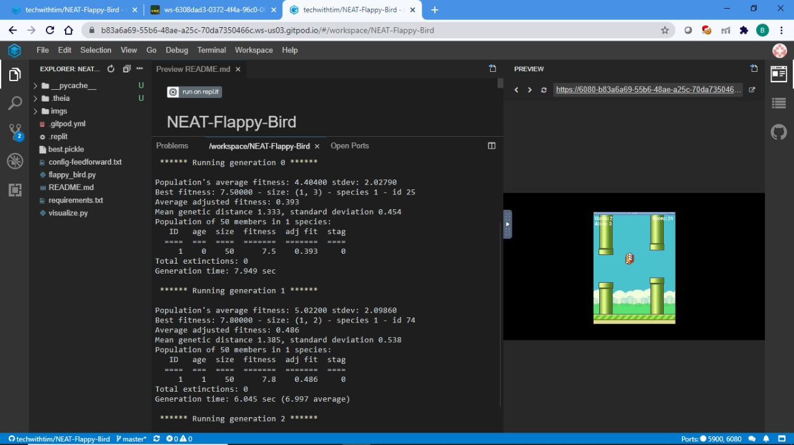

* + 1. NEAT Flappy-Bird Metrics
  1. Training AI using Unity ML-Agents

Standard built-in environment called 3D Ball was used for training from scratch using mlagents-learn. The main aim is to balance ball by adjusting rotation of box below. Unity’s Physics Engine is used to create virtual environment and realize game mechanics. C# script is further used to model behaviour is inherited from Agent class which provides framework for Reinforcement Learning.

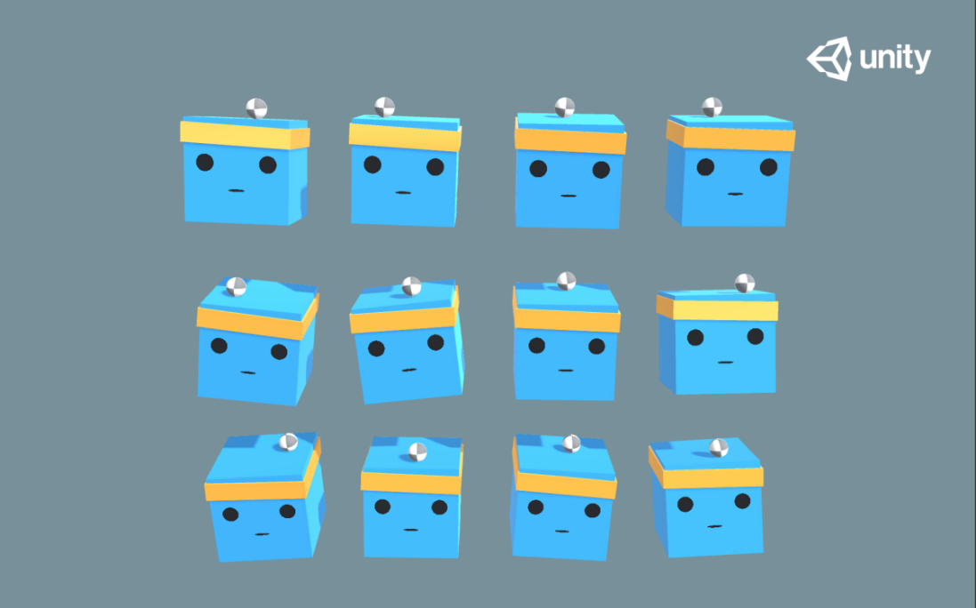

* + 1. 3D Ball Game Still [10]

For training first the environment was built and then ‘config.yaml’ file was used for specifying hyper-parameters for training. Training was done on Google Colab platform and Tensorboard was used for evaluating model metrics. At end of training we get ‘.onnx’ file which contains the model Neural Net model which can be used to control the environment in Unity.

These three parts are always generated during the training process.All parts are located in the results folder:

* Summary: These are the training indicators updated during the training process, which is very useful for monitoring how well model is performing and can help get information about updating hyperparameter values.
* Model: Contains model breakpoints and final model (.onnx) files updated during training. At the end of training, the model file will be created.
* Timer file (in run_logs): Contains total metrics about model learning process, including where time spent specific to code blocks.

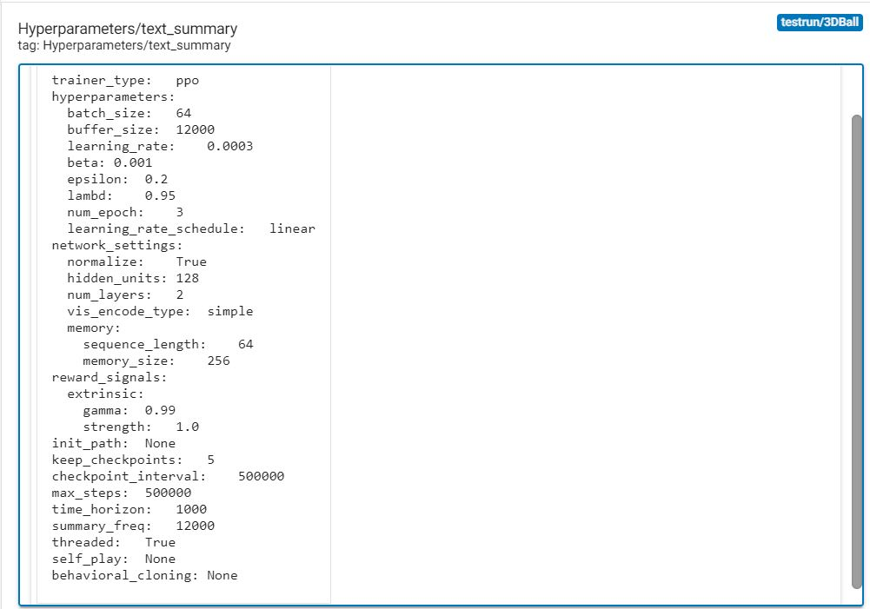

* + 1. Hyper-parameters for 3DBall Environment

Following are metrics for inbuilt 3DBall Environment after training with mlagents-learn with 500k steps.

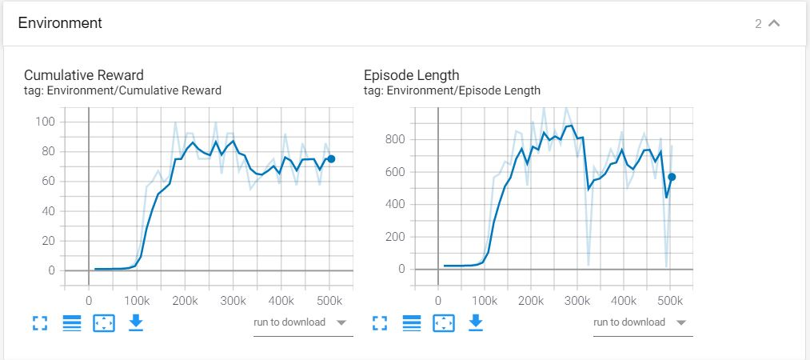

* + 1. Environment Metrics

Above we can see the environment metrics namely cumulative reward and episode length. The cumulative reward correspond to the rewards added up till the simulation is running and we can see that it has increased as the training steps have increased as model learns to guide itself in environment. Episode length is duration for which the simulation has been running till it has ended as defined in environment when ball falls off the box. It is increasing as steps are increasing which tells us that the model is learning properly and successfully.

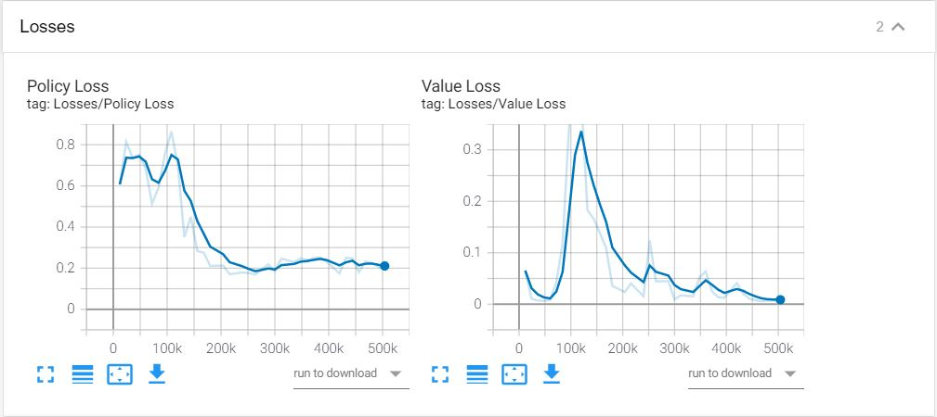

* + 1. Training Loss Metrics

The training losses here are namely policy loss and value loss. Policy loss corresponds to policy loss function defined for PPO and tells us how the policy is changing. Here we see downward trend and tell us that model has learned well and hence doesn’t need to change policy parameters. Value loss corresponds to value update function and tells us model’s ability to predict the value corresponding to each state. It first increases as model learns and decreases as rewards stabilizes.

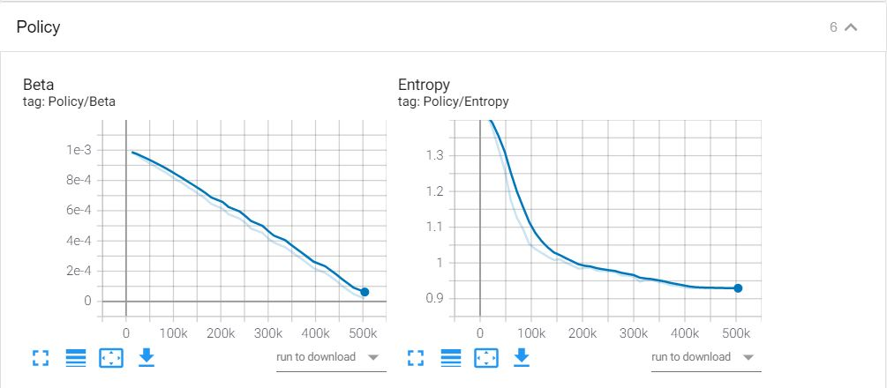

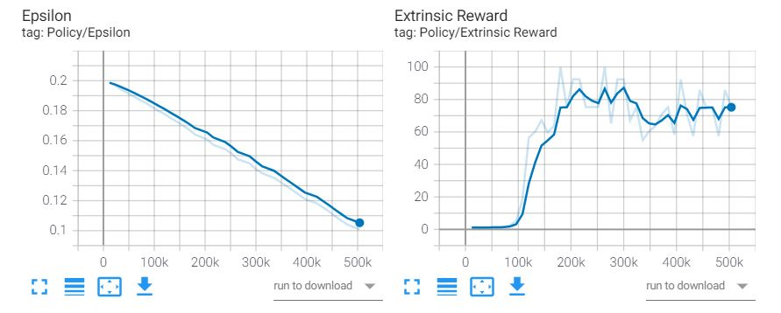

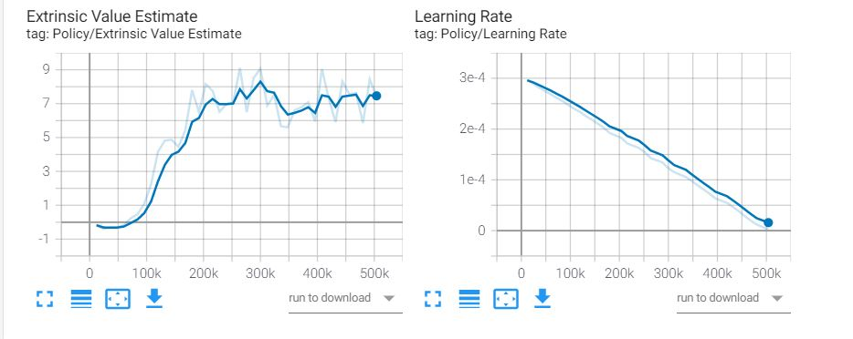

* + 1. Training Policy Metrics

Above we have policy metric parameters namely beta, entropy,epsilon, extrinsic reward, extrinsic value estimate and learning rate. Beta is used for regularising entropy and introduce randomness in policy decision. This is required so that environment can be explored completely by agent. In plot we can see that it is increasing as rewards are increasing. Entropy tells us randomness of model decisions. Here we see that it is decreasing steeply as model learns and doesn’t depend on random actions.

Extrinsic reward is tell us about models anticipation for future rewards and its decision regarding current action so that reward can be obtained in future. In graph we can see that it increasing and then stabilising as it has learned about reward actions. Extrinsic value estimate is estimate of rewards that model thinks it can obtain in future at any given time and in graph we see similar trend with that of extrinsic reward.

Epsilon decides how quickly the policy is allowed to evolve while training. Here we have reduced it linearly. Learning rate is defines the effective weight for updating policy using gradient descent.

* 1. 3D-Printing Physical Model for Assistant

After going through internet and coming across various models for Haptic feedback hand, we selected model provided by Alex Czech on thinkverse Copyright©, keeping feasibility and functionality provided by each design. It is exoskeleton which uses 3d-printing technology for making sub-parts of hand assembled using nuts and bolts. The design incorporates bi-directional DC motor for providing movement in fingers. This design provides 1 Degree of Freedom for each finger. The open source .stl file is obtained from thingverse and using it 3D model is printed using 3D printer with the following specification:

* Resolution: 0.2mm
* Filament: ABS
* Infill%: 50
* Quality: Standard

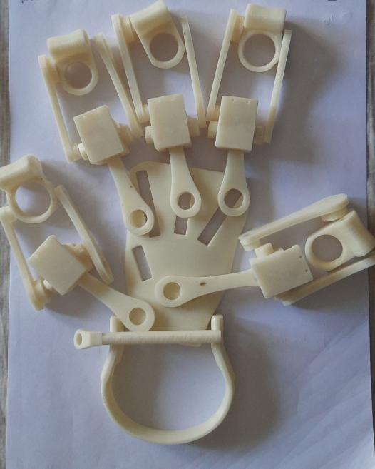

* + 1. 3D-Printed parts of Assistant
  1. Mechanical Assembly of 3D-Printed Parts

After drilling holes & smoothing parts using nuts and bolts we have assembled the 3D-printed parts. And while checking for functionality it worked as per requirements but movement was bit restricted. We have attached 4 fingers to model and each finger has Single DOF and it fits hand prefectly.

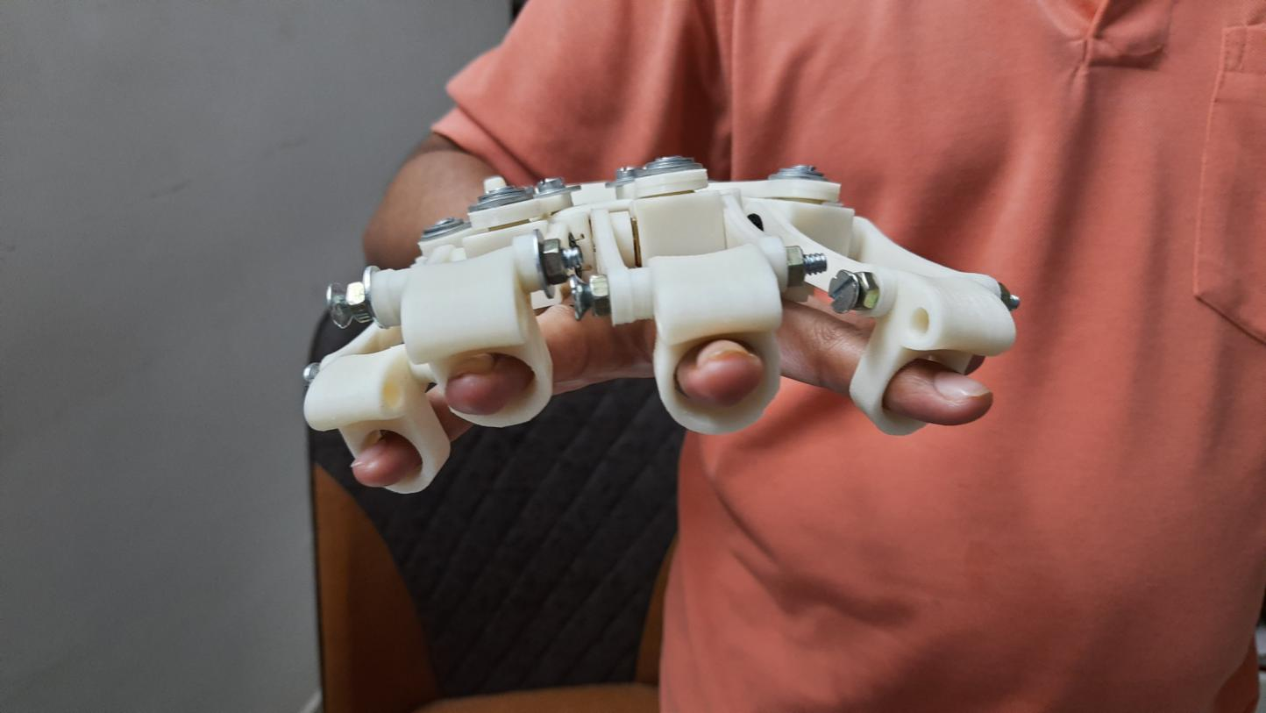

* + 1. Front View of Assembled Parts

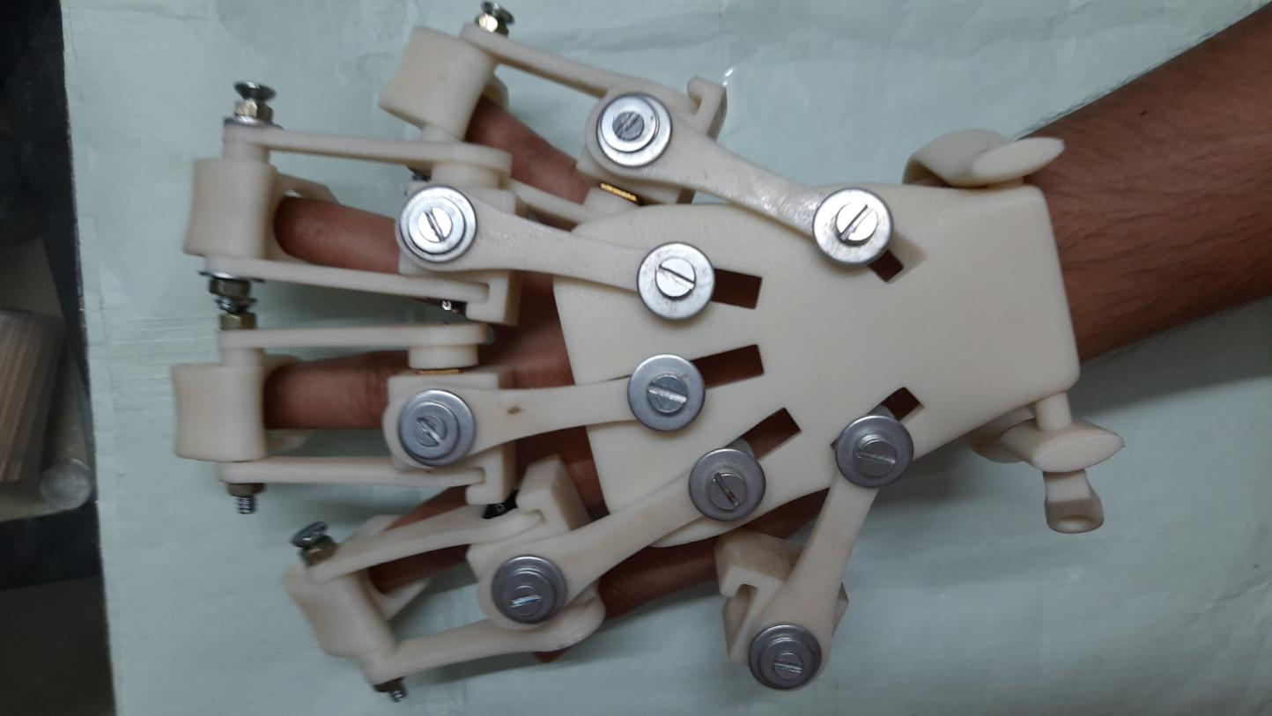

* + 1. **Top View of Assembled Parts**

* 1. Adding Electronic Components

After assembling mechanical parts, we place motors in the slot provided in 3D printed part and add connecting wires. These are then connected to Arduino and functionality of DC motors is checked.

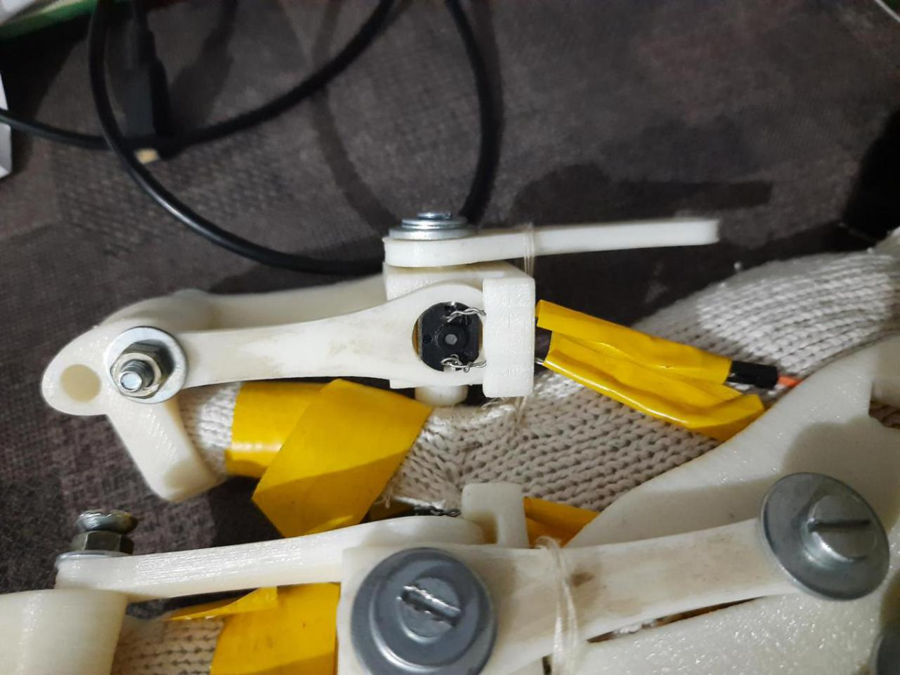

* + 1. DC Motor Fitting and Wiring Side View

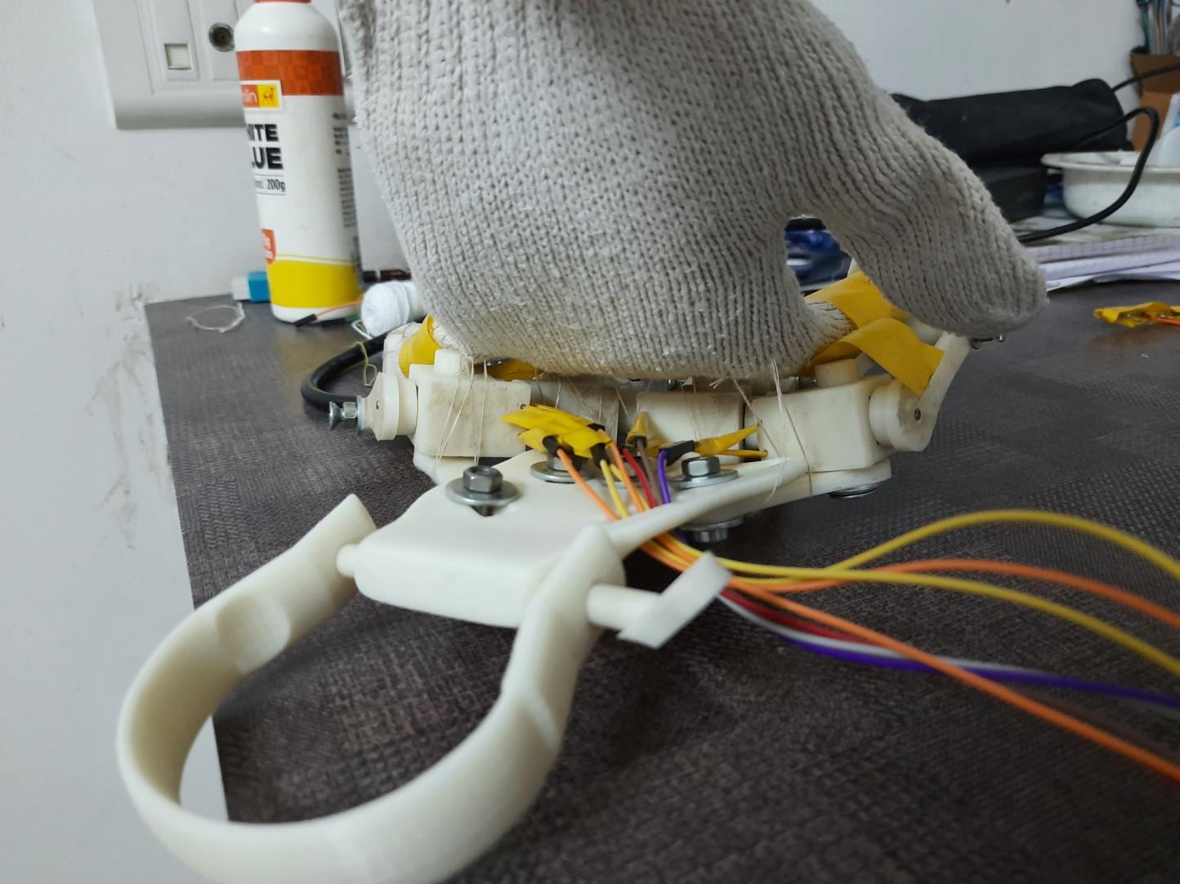

* + 1. DC Motor Wiring Back View

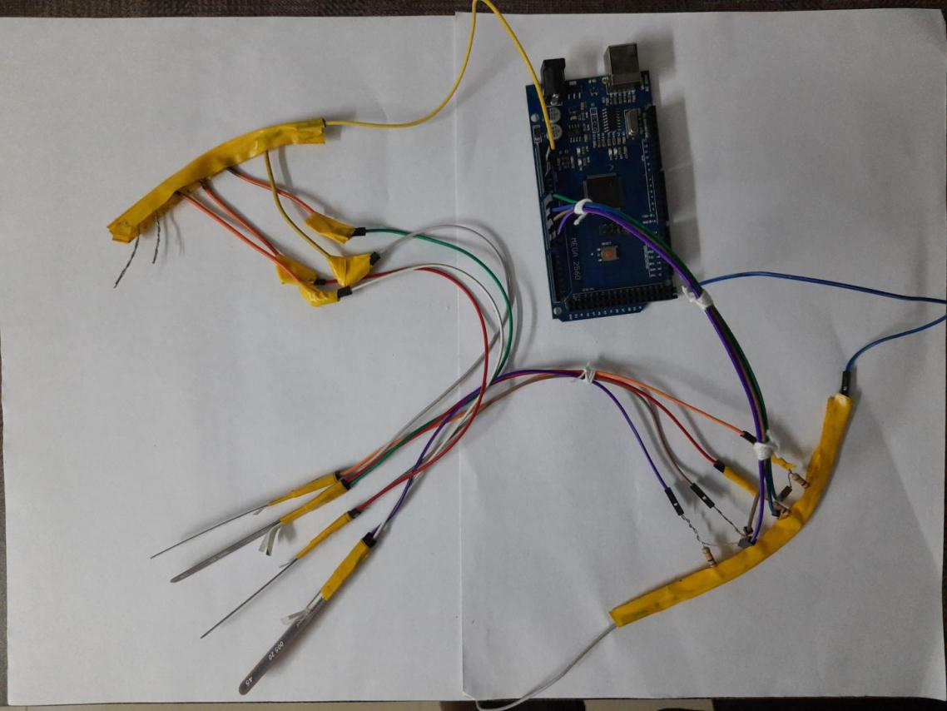

* + 1. Flex sensor Interface with Arduino

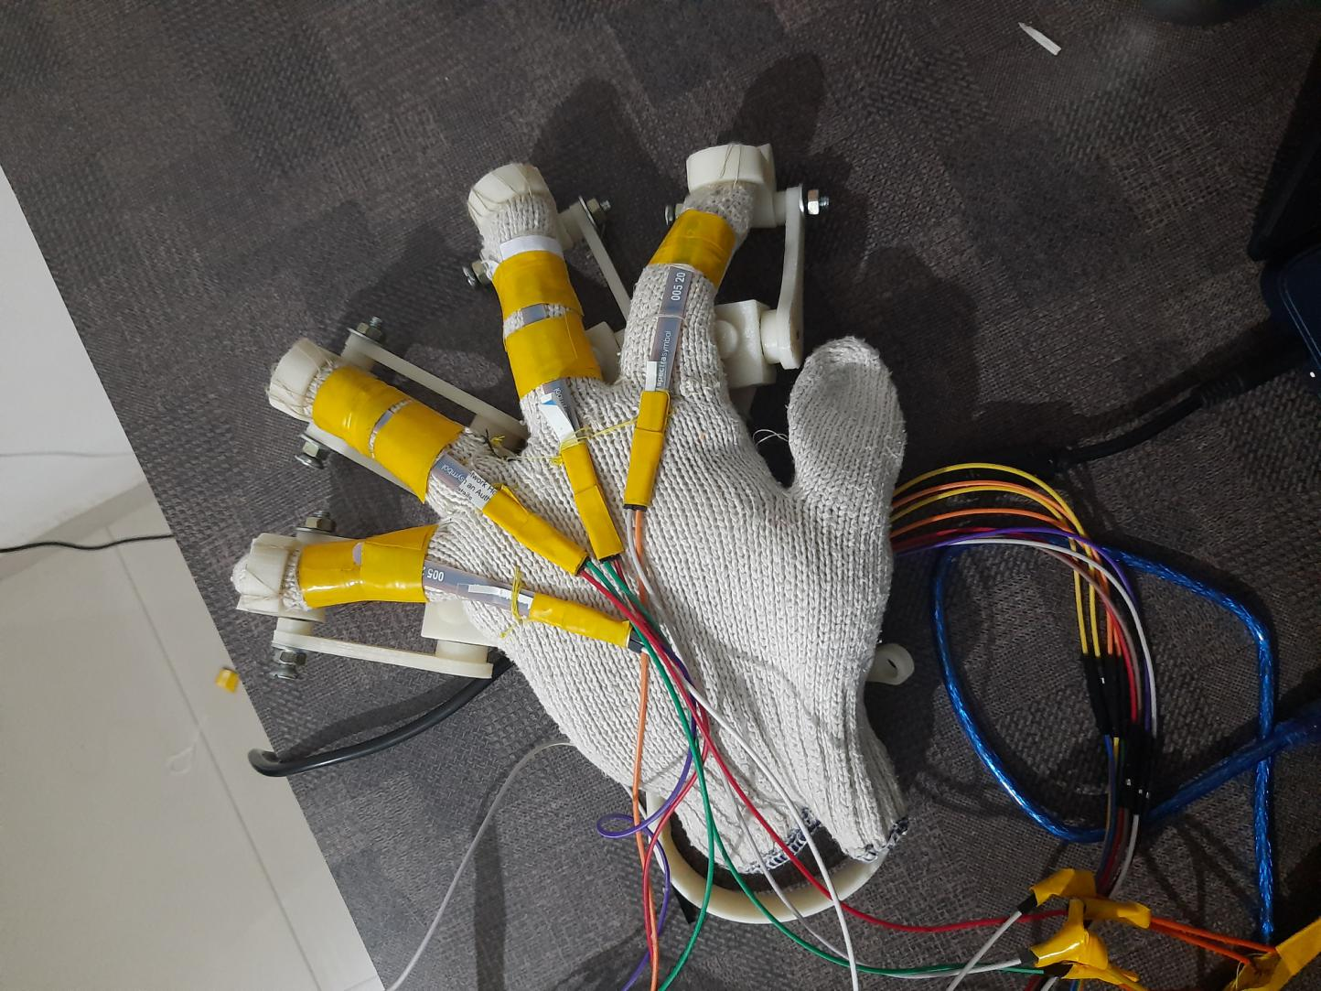

* + 1. Flex Sensor placing on Assistant
  1. Creating Working Prototype using Arduino

As explained above bi-directional DC motor is connected to the Arduino Mega at PWM Pins. The speed, angle and steps of bi-directional DC motor we can control using Arduino and Flex-sensor. We have connected Arduino to bi-directional DC motor and our 3D printing hand.

The movement of this 3D hand is controlled by the Arduino using flex sensors that are connected at analog input pins which provides us voltage values which in turn is used to control game mechanics. The flex sensor is like a variable resistor as explained above is connected from 3D hand. When we make movement in 3D hand then this flex sensor will bend accordingly. When this sensor bends the resistance value of this flex sensor will changes. Further the output of the flex sensor decides action to the game and hence it will control the game. Input of the Arduino is from game which is connected to games’ AI model using Serial Communication. We have trained this AI model using Unity ML-agents.

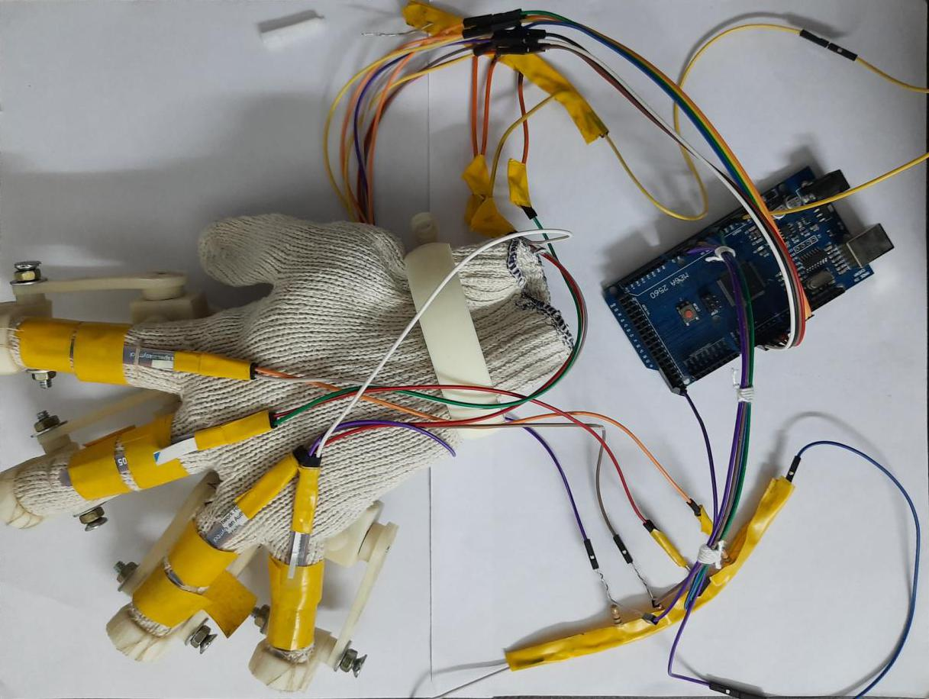

* + 1. Completely Assembled 3D Hand Assistant

After flex sensors and DC motors are placed on Assistant model they are interfaced with Arduino. A test Arduino sketch is uploaded in which the each finger is moved within the threshold values of flex sensor. We use array jump to control the motors. The jump[i] takes three values ‘0’, ‘1’ and ‘-1’ which correspond to Up, Down and Stop State of motors respectively. The jump array is initialised with 0. When ith motor reaches up threshold jump[i] is changed to 1 and when it reaches down threshold it is changed to 0. If due to some situation the flex sensor goes out of max threshold values jump[i] is changed to -1 and the motor is stopped. Below we have presented motors in up and down state and corresponding jump values shown in Arduino Serial Monitor.

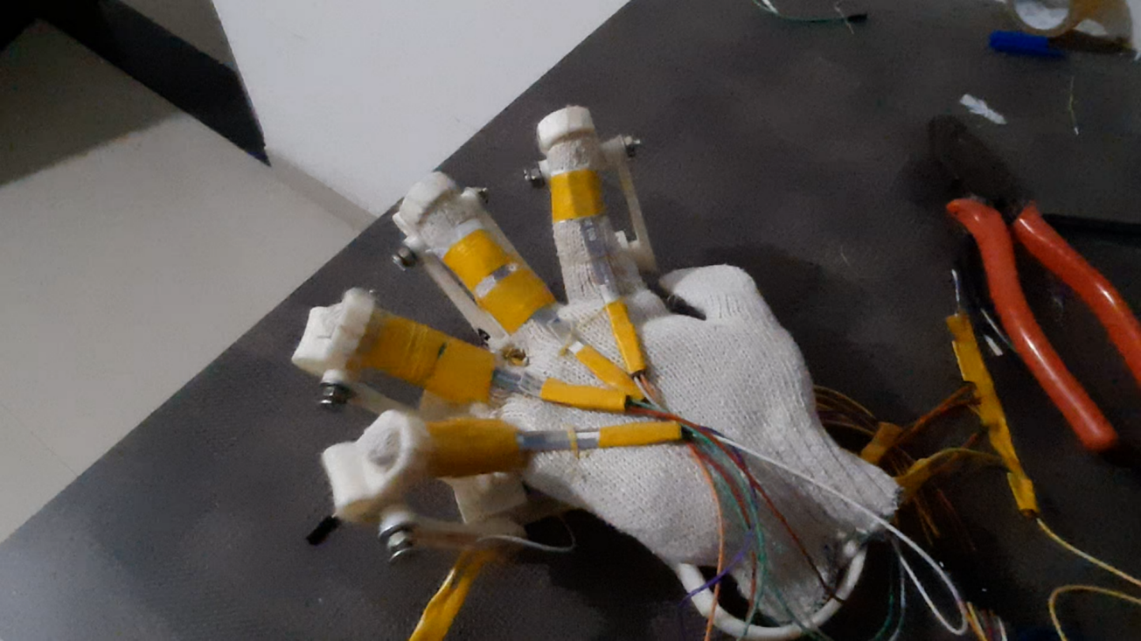

* + 1. Motors in Up Motion Still

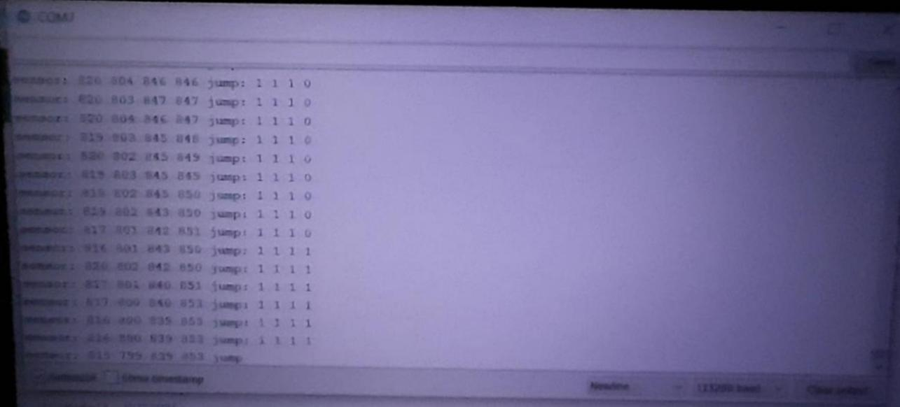

* + 1. Arduino Test Input and Sensor Values for Down

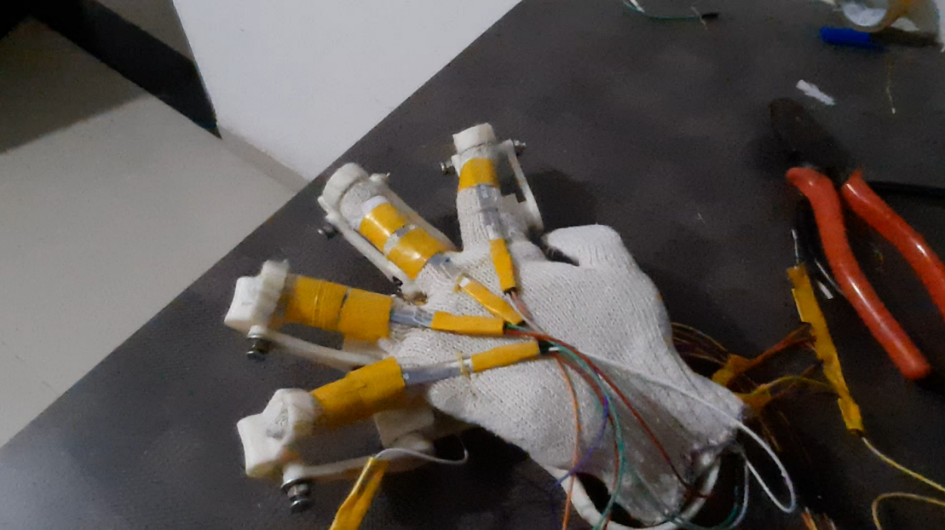

* + 1. Motors in Down Motion Still

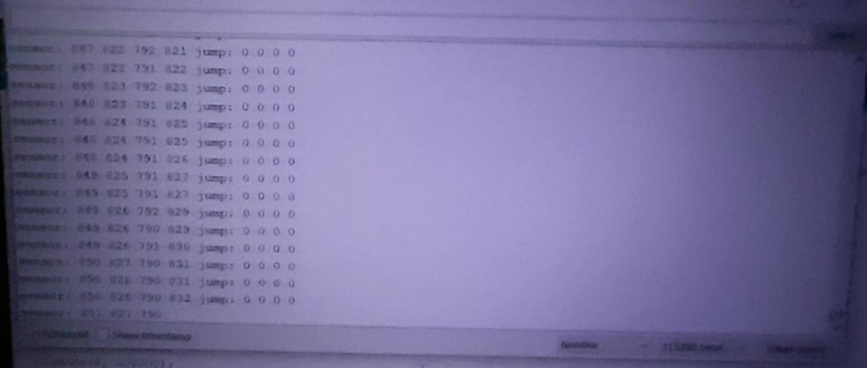

* + 1. Arduino Test Input and Sensor Values for Down
  1. Arduino Unity-C# end-to-end Serial Communication

For testing and establishing serial communication between Arduino and Unity we have created a scene in Unity where block on left plane can be controlled from keyboard which is then send to Arduino through serial communication. Arduino motor then moved motor corresponding to lookup table. Once action was complete acknowledgement is sent to Unity on serial line. After receiving acknowledgement from Arduino the block on right plane is moved with same values as on left one.

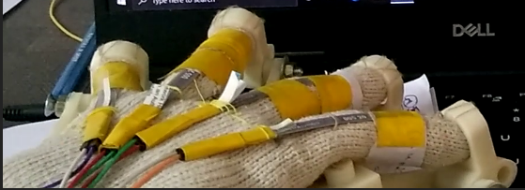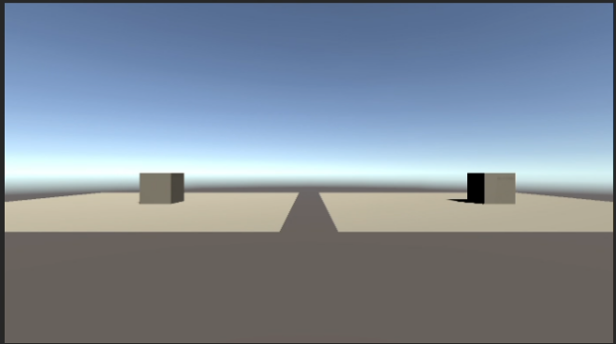

* + 1. Before “Left” Signal from Unity

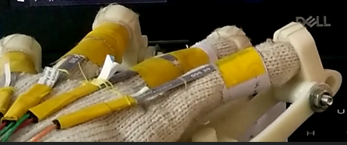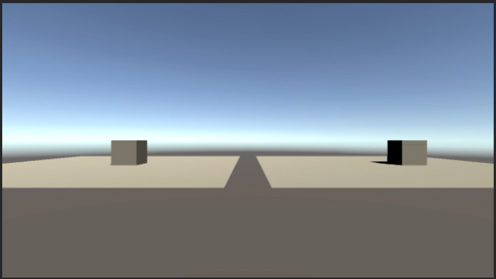

* + 1. After “Left” Signal Completed from Arduino

The following lookup table was followed for Arduino Unity Serial Communication. And correspond to arrow keys from which left block can be controlled from keyboard.

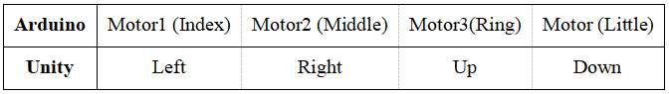

Table 6.9.1Arduino Unity Look-up Table

In figure below we can see the log of Serial Communication. *“Unity C#”* correspond to one sent from Unity to Arduino as control signal. Further *“Arduino ->||”* correspond to acknowledgement received from Arduino to Unity for action signal. And *“Moved”*  correspond to replication of action on right block as that was done on left one before sending the action signal.

We can see *“Hello”* which is done at starting of Serial Communication for checking purpose. Each of four motors are moved using Unity and corresponding ACKS are received from Arduino and corresponding action taken on right block.

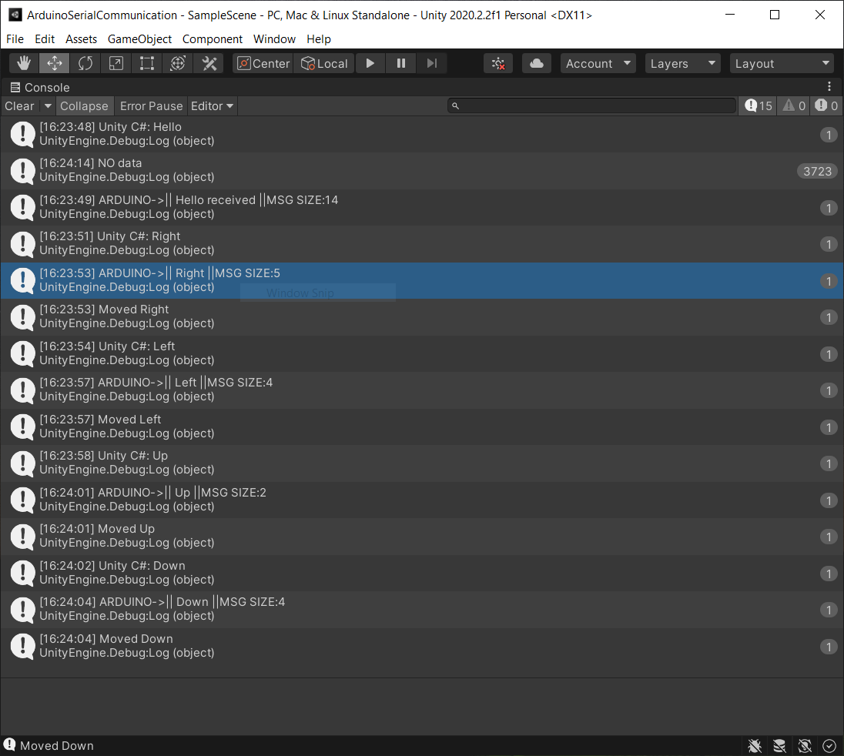

* + 1. Serial Communication Log
  1. AI Controlled Haptic Assistant

We have used Unity environment called *‘Jumping Cars’[15]* as avaliable on github. It is basic endless jump game as discussed before. The environment provides Agent which can jump once it detects obstacles and uses “*Ray Perception Sensor 3D”* and AI model to do so. The score increases for each successful jump to avoid obstacle which also acts as reward for AI training. For each unsuccessful jump the game is ended and -1 reward is added.

The model for Game AI is trained as done before for 3DBall using Google Colab. Necessary changes in code is done for integrating Serial Communication between Unity and Arduino as described before. Unity Agent mechanics is changed so that action can be requested once Arduino completes the previous action. The respawn rate is between 3-4 seconds keeping in mind that total latency of Assistant is 2 seconds.

The each motor is used sequentially of jump and below is lookup table for communication between Arduino and Unity Serial Communication.

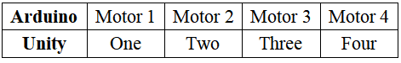

* + 1. Table 6.10.1 Arduino Unity Lookup Table

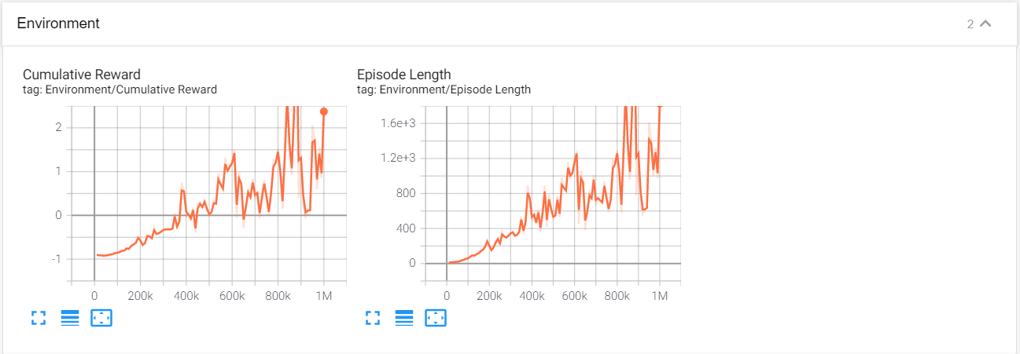

* + 1. Environment Metrics of Jumping Car AI

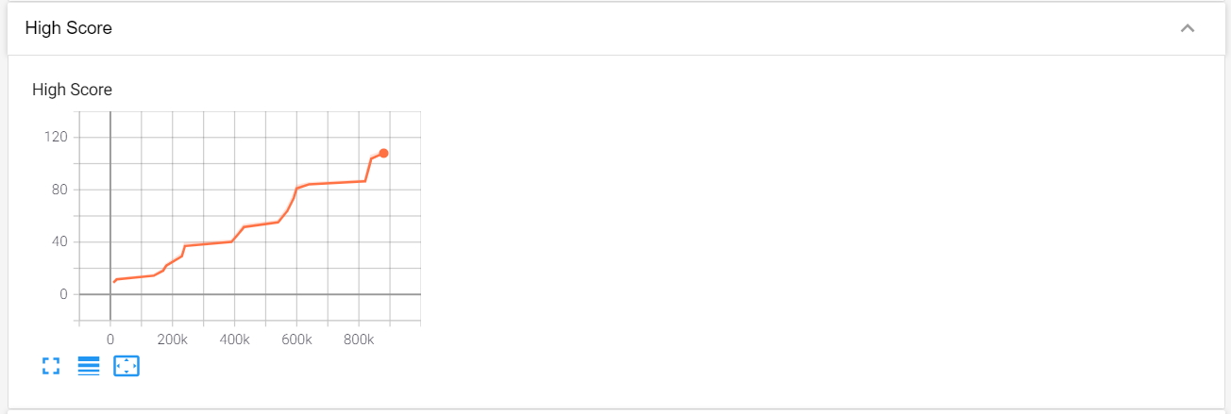

* + 1. High Score in Episodes of Jumping Car AI

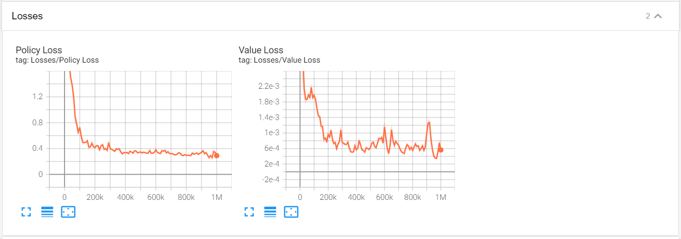

* + 1. Loss Metrics of Jumping Car AI

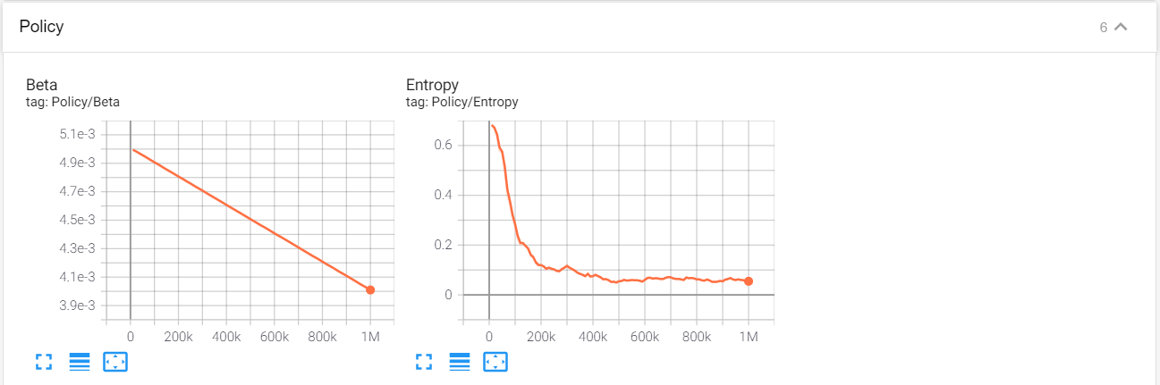

* + 1. Policy Metrics of Jumping Car AI

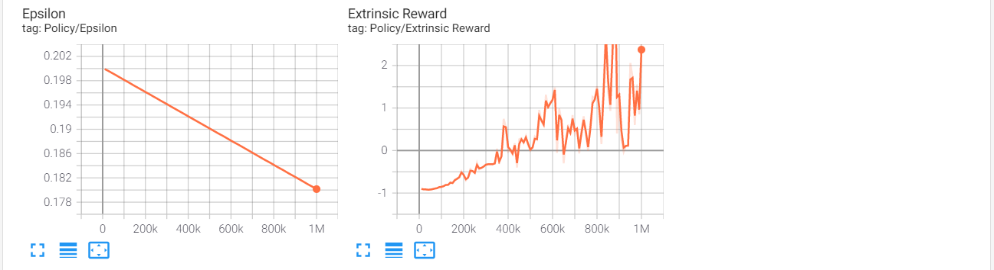

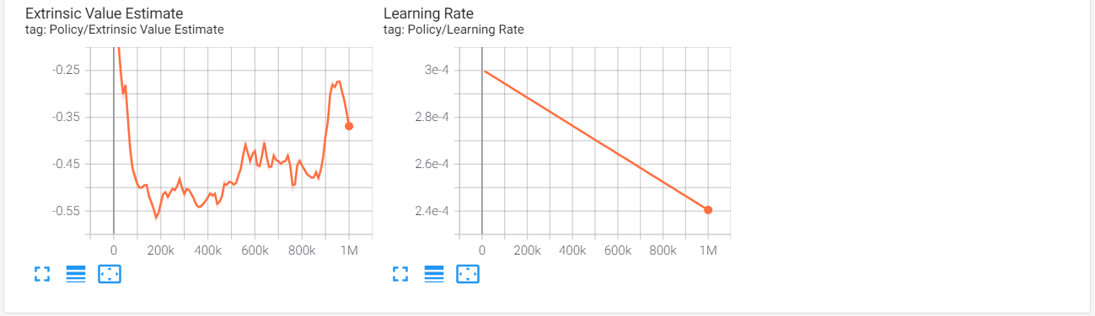

* + 1. Other Policy Metrics of Jumping Car AI
    2. As discussed before the metrics show that training of Jumping Car AI. Increasing Cumulative Rewards, Episode Length and High Score with decrease in Policy Loss, Value Loss and Entropy tell us that the training of AI went well and was successful.
    3. Using the trained AI and updated Unity Environment with have finally simulated the complete feedback cycle. First AI detects the obstacle and sends Arduino action signal. Arduino performs the action and sends back acknowledgement to Unity. Unity performs the jump and after successful attempt the score is updated.

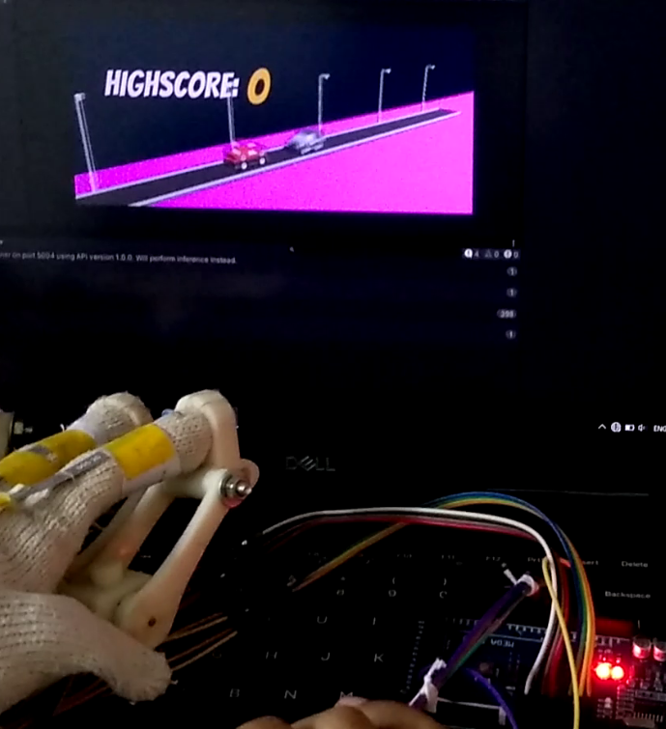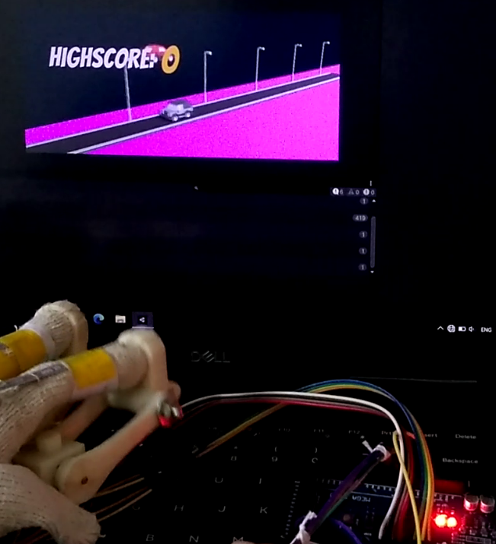

* + 1. Game AI Controlling Motor 1 as it senses obstacle

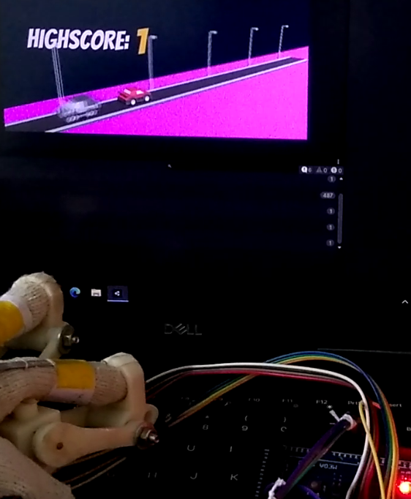

* + 1. Score Update after successful attempt

Below we have Serial Communication log for same and follows same format of *“Unity C#”* and *“Arduino->||”* for Unity and Arduino actions respectively and *“Received ACK”* for acknowledgement from Arduino. We have received 8 ACKs when each of four motors moved twice while gameplay.

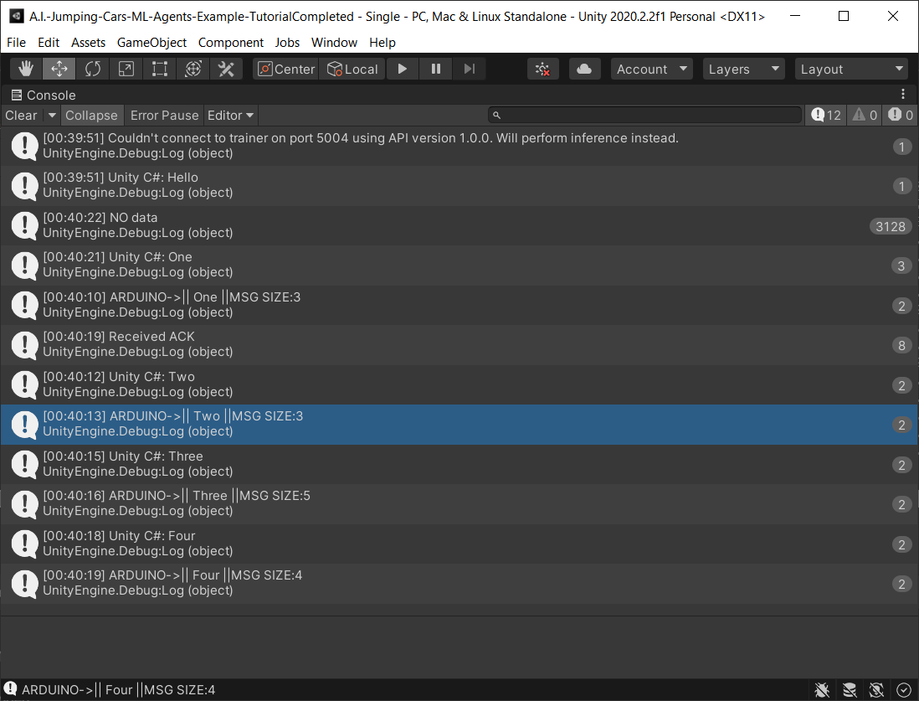

* + 1. Serial Communication Log for Final Prototype

# Chapter - 7

1. CONCLUSION

Assistant is completely assembled and working prototype using Arduino is created completing Hardware part of project. From various tutorials and open source prefabrication we have attempted to create Unity environment in where these actual games can be played. These will also act as environment for AI training. We have tried and tested Convolutional Neural Networks, Deep Q-Networks and Neuro-Evolution of Augmented Technologies while exploring various AI algorithms. Standard Unity environment is trained from scratch using PPO algorithm. Serial Communication between Unity Environment and Arduino is tested successfully. Finally Unity Game AI and Arduino controlled Assistant is integrated and fully AI feedback controlled Haptic Assistant is made.

Future trends and work

Our main was to make 3D printed exoskeleton which can be controlled using AI. During implementation we found various improvements that can be included with future versions and are as follows:

* Making use of complex game mechanics or virtual environment which have more actions and responses in 3 dimensional space further enriching the experience.
* We have trained model using discrete action space for easier training further deploying complex virtual environment would require continuous action space for better handling agent and decision making.
* Better model of Assistant with more degrees of freedom to incorporate wide range of actions and functions.
* Arduino has doesn’t support multi threading hence the latency time increases as control mechanics increase and become more complex hence using board with multi-threading can reduce latency as each motor can have its own thread.
* We have used only flex sensor for sensing bend but additional sensors can be used to track movement precisely and add more functionality and control aspects.

2. REFERENCES
3. Czech, A., 2015. 3D PRINTED EXOSKELETON HANDS - IN ONE PIECE. [image] Available at: *https://files.cults3d.com/uploaders/3695667/illustration-file/1435670806-19154-8542/Exo-Hand_Left_One_Piece_ISO_View_large.JPG>* [Accessed 25 November 2020].
4. A. Imran, “Training a Robotic Arm to do Human-Like Tasks using RL,” Data Driven Investor, 28-Feb-2019. [Online]. Available: *https://medium.com/dastadriveninvestor/training-a-robotic-arm-to-do-human-like-tasks-using-rl-8d3106c87aaf.* [Accessed: 25-Nov-2020].
5. Perret, Jérôme & Vander Poorten, Emmanuel. (2018). Touching Virtual Reality: a Review of Haptic Gloves.
6. D. Marwah, S. Srivastava, A. Gupta, and S. Verma, “Chrome Dino Run using Reinforcement Learning,” arXiv [cs.AI], 2020.
7. Wikipedia contributors, “Q-learning,” Wikipedia, The Free Encyclopedia, 20-Oct-2020. [Online]. Available: *https://en.wikipedia.org/w/index.php?title=Q-learning&oldid=984486286.* [Accessed: 25-Nov-2020].
8. A. Juliani et al., “Unity: A general platform for intelligent agents,” arXiv [cs.LG], 2018.
9. "An introduction to Q-Learning: reinforcement learning", freeCodeCamp.org, 2018. [Online]. Available: *https://www.freecodecamp.org/news/an-introduction-to-q-learning-reinforcement-learning-14ac0b4493cc/*. [Accessed: 25- Nov- 2020].
10. "Understanding the Role of AI in Gaming", AiThority, 2020. [Online]. Available: *https://aithority.com/computer-games/understanding-the-role-of-ai-in-gaming/*. [Accessed: 25- Nov- 2020].
11. "What Is AI in Gaming? – Arm", Arm.com, 2020. [Online]. Available: *https://www.arm.com/glossary/ai-in-gaming.* [Accessed: 25- Nov- 2020].’
12. "Unity-Technologies/ml-agents", GitHub, 2021. [Online]. Available: *https://github.com/Unity-Technologies/ml-agents/blob/0.15.1/docs/Getting-Started-with-Balance-Ball.md.* [Accessed: 31- Mar- 2021].
13. “techwithtim/NEAT-Flappy-Bird", GitHub, 2021. [Online]. Available: *https://github.com/techwithtim/NEAT-Flappy-Bird*. [Accessed: 31- Mar- 2021].
14. Orozco, Mauricio & Silva, Juan & El Saddik, Abdulmotaleb & Petriu, Emil. (2012). The Role of Haptics in Games. 10.5772/32809.
15. Ben-Tzvi, Pinhas & Ma, Zhou. (2014). Sensing and Force-Feedback Exoskeleton (SAFE) Glove. IEEE Transactions on Neural Systems and Rehabilitation Engineering. 23. 10.1109/TNSRE.2014.2378171.
16. Mnih, Volodymyr & Kavukcuoglu, Koray & Silver, David & Graves, Alex & Antonoglou, Ioannis & Wierstra, Daan & Riedmiller, Martin. (2013). Playing Atari with Deep Reinforcement Learning.
17. S. Schuchmann, "Sebastian-Schuchmann/A.I.-Jumping-Cars-ML-Agents-Example", GitHub, 2020. [Online]. Available: https://github.com/Sebastian-Schuchmann/A.I.-Jumping-Cars-ML-Agents-Example/tree/TutorialCompleted. [Accessed: 11- Apr- 2021].